SmartCare v0.4 - Domain Implementation Workbook
Week 7 student resource

1. UML-to-Code Trace
UML element | Python element | Implemented? | Notes
Class Practitioner | class Practitioner | Yes | None
- practitionerId: int  - name: str  - speciality: str | self._id, self._name, self._speciality | Yes | A bit changes in the naming convention, for example I used id instead of practitioner id within prac class, because it is industry practice, and within same class we keep UUID/int as id typically.  Used underscore to tell that these vars are all private. (Python does not enforce any private access, we use naming conventions to enforce it ourselves in coding).
- getPractitionerDetails()  - setPractitionerDetails() | get_practitioner_details(),  set_practitioner_details(name, speciality) | Yes | None, works as intended.
Association: 1 Practitioner is booked by 0..* Appointment | Appointment._practitioner_id | Partially Yes | Practitioner class has no list of all appointment dictating this relationship, although it is enforced implicitly and will be further strengthen thru service,repo and db. (this is because to keep single source of truth)
Class Appointment | class Appointment | Yes | -
- id: int  - patientId: int  - practitionerId: int  - timeSlot: dateTime  - Status: AppointmentStatus | self._id, self._patient_id, self._practitioner_id, self._timeSlot, self._status.  class AppointmentStatus(Enum) | Yes | -
- getAppointmentDetails(),  - updateAppointment(),  - cancelAppointment() | get_appointment_details(),  update_appointment(all params),  cancel_appointment() | Yes | -
- bookAppointment() | - | No | The constructor already initializes the instance and serves the same purpose.
Class Patient | class Patient | Yes | -
- patientId: int  - name: str,  - email: str,  - medicalHistory: List[str] | self._id,  self._name, self._email, self._medical_history | Yes | Implemented as is, with validations to hold invariants.
- getPatientDetails(),  - getMedicalHistory(),  - validateDetails() | get_patient_details(), get_medical_history(),  validate_details() | Yes | -
Association: 1 Patient books 0..* appointments. | Appointment._patient_id | Partially Yes | Patient class has no list of all appointment dictating this relationship, although it is enforced implicitly and will be further strengthened thru service,repo and db. (this is because to keep single source of truth)

2. Domain Invariants
Class | Invariant / rule | How protected
Patient | Patient_id must be greater than 0. | Only 1 way to update patient id (init), goes through validation.
Patient | Name must not be empty. | Only 2 ways to update name, both goes through validation.
Patient | Email must have @ and . | Only 2 ways to update email, both goes through validation.
Appointment | Appointment, patient, and practitioner ids must be greater than 0. | Validate_details enforces this.
Appointment | TimeSlot must be in the future | Enforced through logic in init and update appointment.
Appointment | Status must be a legal enum, and consistent. (This is the most powerful invariant for the class and for the whole code.) | Through logic, in all functions, in cancel appointment, complete appointment etc, everywhere it is make sure that Status goes from one legal state to another, or no transition takes place. Meaning it can be only invalid within the function, but after the func ends it returns back to its consistent legal valid state.
Practitioner | Patient_id must be greater than 0. | Only 1 way to set id (constructor) goes through validation.
Practitioner | Name must not be empty. | Only 2 ways to set this, goes through validation for both.

3. Composition / Inheritance Decisions
Relationship | Decision | Rationale
1 Patient books 0..* appointments. | Association. | Patient interacts with the appointment instance, uses it, but does not own it if in the future a patient record or instance is deleted, the Appointment records should still stay in place.
1 Practitioner is booked by 0..* Appointment | Association | Practitioner interacts with the appointment instance, same as patient just uses it, if in future prac leaves the clinic the appointment history should stay in the records.

4. AI Pair-Programming Record
AI contribution | Conforms? | Decision | Reason | Verification
Appointment class from the UML, with good type hints, and function/class definitions | Yes. | Accepted. | Fields match the diagram. get, update, and cancel match the UML methods. | Matches original BR’s and Functional Requirement of the major Appointment class.
Checks for positive ids and a future time slot | Partially. | Accepted (Implicit confirmation, doesnt hurt, adds good bit of validation) | These guard the appointment rules. The checks stay small. | Good validation.
complete_appointment() and blocked status changes | Yes from FR. Partially from UML. | Accepted | Not explicitly in UML design. However, it actually is a correct placement, there should be a separate complete appointment function, because we have to measure legal/valid states of status. | Yes, this was one of the few most focused requirements from the start “Consistent Appointment Status”, this function and invariant implies that only.
is_scheduled(), is_completed(), is_cancelled() | No. | Rejected | Not in UML, not in FR, adds extra LoC, not needed. | No mention in FR.
get_status | No. | Accepted. | Even tho its not explicitly mentioned in FR or UML, it acts as a good utility function to get access to status. | No mention in BR or FR.

5. Updated UML
Insert updated UML only if implementation revealed a justified design change. Explain every change
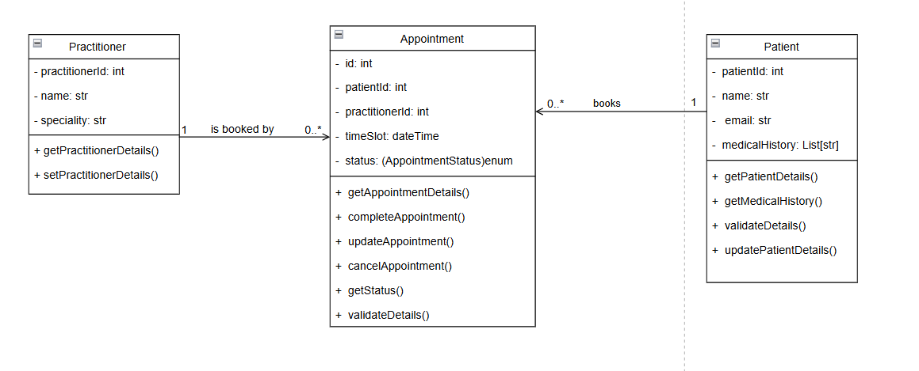Changes:
Removed bookAppointment() function, dont need it we have a constructor to initialize an appointment (which will logically be always booked if first initialized).
Added a completeAppointment() function, because it is necessary to have separate status changing function so we can track the previous state to next state and keep it in separate funcs/concerns.
Added getStatus() and validateDetails() in Appointment class functions both are utility function makes repeatable code set in a routine, and getStatus protects encapsulation and acts as utility.
Added updatePatientDetails() in Patient class, a necessary method to update patient details if needed, comes directly form original case study which said that patients updated information/state should be stored.

